Expt. no: 1 Date:

Introduction to Soldering and Desoldering using a Perforated Board

Objective:
- To test the circuit on a breadboard
- To practice soldering
- To practice desoldering
- To fabricate the PCB on a perforated board
- To verify the working of the PCB using a multimeter and oscilloscope
Precautions:
- This lab involves hot soldering irons and components. USE EXTREME CAUTION!!!
- The solder used in the laboratory may contain lead. DO NOT breathe fumes generated while soldering. Preferably wear masks.
- Be aware of the location of your soldering iron while it is hot and ensure you place the hot iron in an appropriate holder to prevent heat or fire damage.
- Switch off and unplug soldering tools when not in use.
- Allow the soldering tool to cool before storing.
- Wash your hands after using solder and soldering tools.

Equipment:

Instruments: Oscilloscope, Digital Multimeter

Components:
Sr. No. | Items
1 | Step-down transformer
2 | Pin Headers
3 | Diodes 1N4007 (2 no.s)
4 | Resistor (2.2K) (1 no.s)

Other material:
Sr. No. | Items | Sr. No. | Items
1 | Perforated Board | 7 | Flux
2 | PCB Cutter | 8 | Soldering iron
3 | Scrubber | 9 | Helping hand clamps/ Tack
4 | IPA solution | 10 | Face mask
5 | Tissue paper/ cotton | 11 | Brass wire sponge for tip cleaning
6 | Soldering wire | 12 | Wet Sponge for tip cleaning

Theory:

Solder:
The solder used for electronics is a metal alloy, made by combining tin and lead in different proportions. You can usually find these proportions marked on the various types of solders. With most tin/lead solder combinations, melting does not take place all at once. Fifty-fifty solder begins to melt at 183°C (361°F), but it is not fully melted until the temperature reaches 216°C (420°F). Between these two temperatures, the solder exists in a plastic or semi-liquid state. The plastic range of a solder varies, depending upon the ratio of tin to lead. With 60/40 solder, the range is much smaller than it is for 50/50 solder. The 63/37 ratio, known as eutectic solder has practically no plastic range and melts almost instantly at 183°C (361°F).

Flux:
Reliable solder connections can only be accomplished with truly cleaned surfaces. Solvents can be used to clean the surfaces before soldering but are insufficient due to the extremely rapid rate at which oxides form on the surface of heated metals. To overcome this oxide film, it becomes necessary in electronic soldering to use materials called flux. Flux consists of natural or synthetic rosins and sometimes chemical additives called activators to remove oxides and keep them removed during the soldering operation. The flux action is very corrosive at solder melt temperatures and accounts for removing metal oxides. In its unheated state, however, rosin flux is non-corrosive and non-conductive and thus will not affect the circuitry.

Controlling Heat:
Although controlling the soldering iron tip temperature is not the key element in soldering, the advised soldering iron tip temperature is in the range of 343 ~ 398°C (650 ~ 750°F). More importantly, the key element is controlling the heat cycle of the workpiece for reliable solder connections:
- How fast the workpiece gets hot
- How hot it gets
- How long it stays hot
Thermal Mass:
Each joint has its own particular thermal mass, and how this combined mass compares with the mass of the iron tip determines the time and temperature rise of the work.

Surface Condition:
If there are any oxides or other contaminants covering the pads or leads, there will be a barrier to the flow of heat. Even though the iron tip is the right size and temperature, it may not be able to supply enough heat to the joint to melt the solder.

Thermal Linkage:
This is the area of contact between the iron tip and the work. Heat is transferred through the contact area between the soldering iron tip and pad. The tip is also in contact with both the pad and component further improving the thermal linkage.

Workmanship:
Solder joints should have a smooth appearance. A satin luster is permissible. The joints should be free from scratches, sharp edges, grittiness, looseness, blistering, or other evidence of poor workmanship. Probe marks from test pins are acceptable providing that they do not affect the integrity of the solder joint. An acceptable solder connection should indicate evidence of wetting and adherence when the solder blends to the soldered surface. The solder should form a small contact angle; this indicates the presence of a metallurgical bond and metallic continuity from solder to surface.

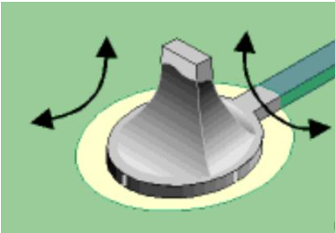
Fig. 1.1 Expected shape of the solder joint

Procedure to perform the experiment:
- Assemble the circuit components on the breadboard and test the working.
- Observe the waveform, note down the output voltage, and calculate the ripple factor. Plot the rectified output graph.
- Fabricate the circuit on the perforated board as per the soldering procedure.
- Desolder and solder the component again till the soldering job is satisfactory, without burning the component.
- Verify the working of the PCB.
- Observe the waveform, note down the output voltage, and calculate the ripple factor. Plot the rectified output graph.
Soldering Procedure:
- Set up the work area with adequate ventilation and a fan to gently blow fumes and vapors away
- Clamp the workpiece securely while performing soldering. Make sure that the workpiece is clean, using abrasion and IPA with cotton.
- Select a correct-sized solder wire and flux. As trace and pad size decrease, soldering tip size must also decrease. Turn the soldering station ON and set the temperature to 343 ~ 398°C (650 ~ 750°F). Note: higher temperatures lead to a more rapid formation of oxidation on the soldering tip and will shorten tip life.
- After the soldering iron reaches the temperature, apply flux to the tip first and then liberally apply solder to the tip. Note: flux-core solder may not require the application of flux. Wipe off excess solder on the sponge. A properly tinned tip will be shiny and free of oxidation. It is normal to have to re-tin a tip from time to time as oxidation builds up on the tip.
- Hold the soldering iron like a pen, near the base of the handle. Touch the soldering iron onto the joint to be made. Make sure it touches both the component lead and the terminal pad. Hold the tip there for a few seconds to heat the joint. Unroll the solder and bring the end to the joint to be soldered near the soldering iron tip. The solder should melt and smoothly flow onto the components to be soldered (component lead, PCB trace, etc). Be sure to apply the solder to the joint, not the iron.
- Remove the solder, then the iron, while keeping the joint still. Allow the joint a few seconds to cool before you move the circuit board.
- Inspect the joint closely. Be sure that the solder joint is good, as described below. Solder joints may be cleaned after they have cooled using isopropyl alcohol and a Q-tip or similar cotton swab.
- Solder Joint Evaluation:
  - Good Solder Joint:
    - will be shiny and concave in nature.
    - will be clean and free of dirt and voids.
    - will fully cover the pad. The component lead lays on or passes through.
  - Cold Solder Joints:
    - Do not make a good electrical or mechanical connection
    - can be remedied by removing existing solder (desoldering and clean-up), and then re-soldered.
- De-soldering is done to remove components that have been soldered together.
  - Use of Vacuum Plunger:
    - To use a vacuum plunger, cock the plunger by depressing it fully until it latches.
    - Bring the vacuum plunger to the location of the joint to be de-soldered. Heat the joint with the tip of the soldering iron.
    - When the solder has melted, press the trigger of the device, which will pull the solder out of the joint.
    - Two or more tries may be needed to fully remove the solder from the joint. On occasion, it is helpful to add solder to the joint to provide additional thermal mass and uniform heating to the joint. This can assist in the complete melting of the solder in the joint
  - Use of Solder Wick:
    - Solder wick is typically a ribbon of braided fine copper wire with rosin core flux impregnated into it. To use a solder wick, lay the wick over the joint to be de-soldered.
    - Apply the heated tip of the soldering iron to allow the wick to be heated and melt the solder in the joint.
    - The solder will flow out of the joint and into the wick through capillary action.

Circuit Diagram:

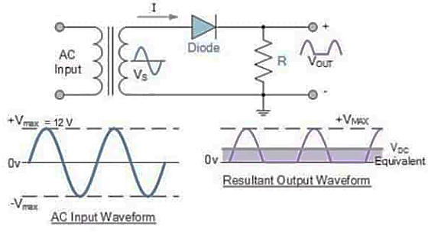

Fig. 1.2 The Half Wave Rectifier Circuit

Implementation: (Remove this content and replace it with photos with the following captions: )
Fig. 1.3 Component-side of the PCB
Fig. 1.4 Solder-side of the PCB
Fig. 1.5 Plot of the output waveform (on a graph page)

Ripple Factor Calculations:

Results:
Measured value of R = ______________
Ripple Factor, breadboard circuit = __________
Ripple Factor, perforated board circuit = __________

Challenges: (write the challenges you faced and overcame, more the challenges you overcome, more the marks)

Conclusion:
Soldering was practiced and performed using a Half Wave Rectifier Circuit on a Perforated Board and its working was verified.

